

Software Development Process Document for Sri Roja Shabarish Guruji Souharda Sahakari Niyamitha:

1. Project Overview
Objective:
To design and develop a secure, user-friendly software system to manage Credit Cooperative Society operations — including member registration, deposits, loans, accounting, and compliance with State Cooperative laws.
Stakeholders:
- Society Management Committee
- CEO
- Advisor
- Software Development Team

2. Scope of the Project
Core Modules:
- Member Management
- Purpose: To manage all member-related information from registration to exit.
Workflow:
- New Registration
- Member fills registration form (name, address, ID proof, photo and nominee).
- KYC verification (Aadhaar, Photo, Pan card) → Admin approval.
- System generates unique Member ID.
- Share Capital Management
  - Member purchases society shares (fixed share value or variable processing charge).
  - Share ledger updated automatically.
- Membership Ledger
- Tracks contributions, loans, deposits, and dividends.
- Deactivation / Exit
- On resignation or death → system calculates refund or settlement.
- Status marked “Inactive” after approval.(No of days to mark inactive has to be given)
Outputs:
  - Member list with KYC details
  - Share certificate or statement
  - Active / inactive member reports
2. Deposit Management:
Purpose: To handle all recurring deposits, fixed deposit.
Workflow:
- Account Creation
• Admin opens a deposit account for a member.
• Select scheme (RD, FD, or Savings) and duration.
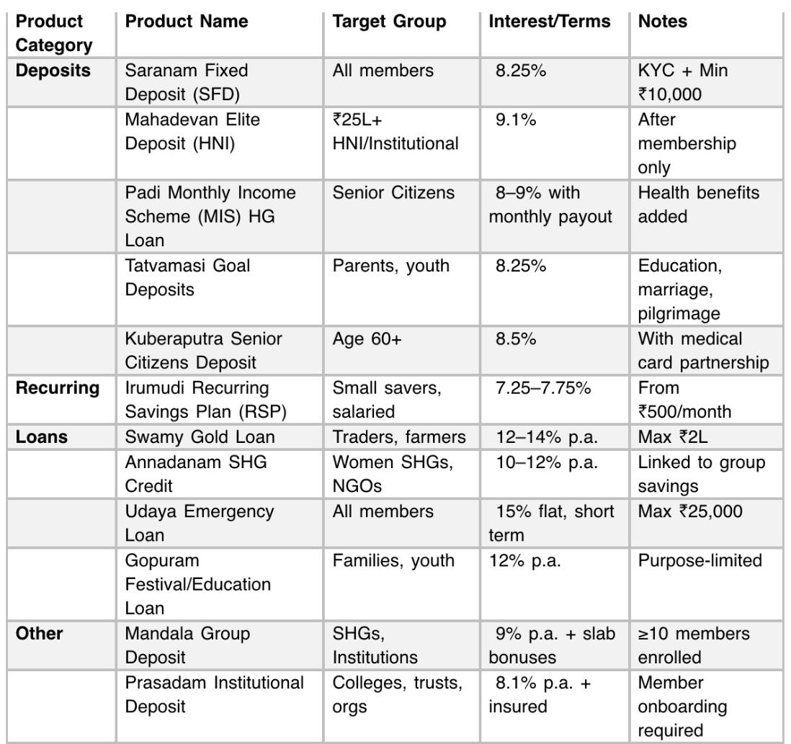
- Collection
• Cash, cheque, or online payment.
• Auto-entry into member ledger and day book.
- Interest Calculation
• Periodic computation (monthly/quarterly/yearly).
• Auto-posting to account at maturity.
- Maturity / Closure
• On maturity date → auto-generate payout amount.
• Option to renew or transfer to another account.
Outputs:
  - Deposit register
  - Maturity alerts
  - Scheme-wise interest report
3. Loan Management
Purpose: To automate loan application, approval, EMI tracking, and recovery.
Workflow:
1. Loan Application
  - Member submits request → loan type, amount, guarantors, and purpose.
  - System checks eligibility (shares, deposits, repayment capacity).
2. Approval Workflow
  - Manager reviews → approves or rejects.
  - On approval → loan account created.
3. Disbursement
  - Funds released to member’s account.
  - Loan ledger and general ledger updated.
4. Repayment / EMI
  - Auto EMI schedule generated (interest + principal).
  - Receipts posted on payment.
5. Overdue Management
  - Alerts for unpaid EMIs.
  - Recovery and penalty tracking.
Outputs:
  - Loan ledger
  - EMI due report
  - Recovery & overdue report
  - Regulatory Daily report

4. Accounting & Finance
Purpose: To maintain books of accounts automatically integrated with all transactions.
Workflow:
1. Transaction Posting
• Every deposit, loan, or expense auto-updates general ledger.
2. Cash Book & Day Book
• Daily summary of receipts and payments.
3. Ledger Management
• Chart of accounts predefined for society heads (e.g., Member Deposits, Loans, Interest Income).
4. Reports & Financials
• Trial Balance, Income/Expense statement, Balance Sheet.
5. Audit Support
• Exportable reports for annual audit submission.
Outputs:
• Financial statements
• Daily cash flow report
• Year-end balance sheet
5. Dividend & Profit Distribution
- Purpose: To calculate and distribute profits/dividends among members.
Workflow:
1. Profit Calculation
• Annual income and expenses computed from accounts.
2. Dividend Setup
• Admin enters dividend rate (as approved in AGM).
3. Distribution
• System calculates member-wise dividend based on shareholding.
• Auto-credit to member ledger or deposit account.
4. Reporting
• Dividend register generated for audit.
Outputs:
• Dividend calculation sheet
• Member-wise payout report
6. Administration & Reports
Purpose: To manage users, permissions, system security, and MIS reporting.
Workflow:
1. User Roles & Access
• Define roles: Admin, CEO, Pigmy Collector, Teller and Director
• Role-based access control for modules and actions.
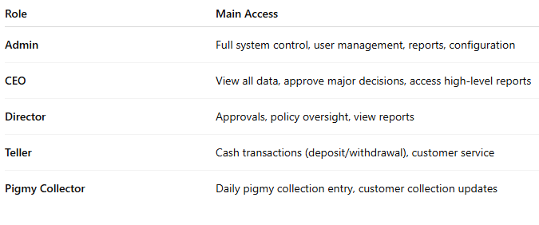
2. Audit Trail
• Every change (creation/edit/delete) logged with timestamp and user ID.
3. Reports
• Financial reports (Cash Book, Day Book, Trial Balance)
• Operational reports (Active Members, Loan Summary, Deposit Analysis)
4. Backup & Data Security
• Regular backup scheduling and restore options.
Outputs:
• User activity log
• Regulatory reports for Registrar
• Backup and restore logs
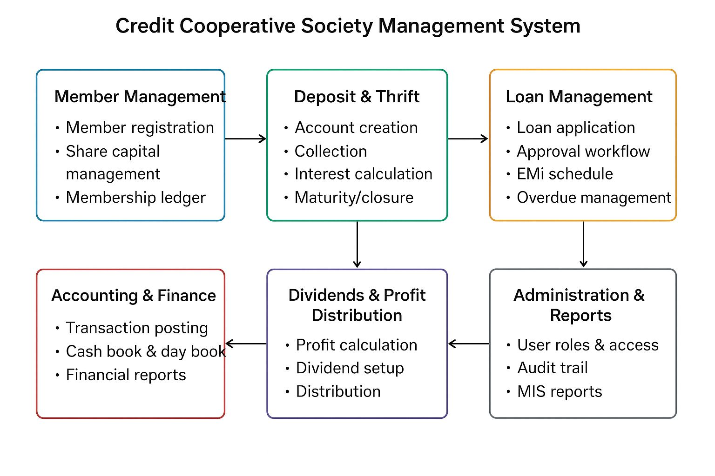

3. Security and Compliance
- Adherence to State Cooperative Act and Audit guidelines
- Data encryption and secure authentication
- Regular data backups and activity logs
- Access control for staff and auditors

